Ed Stafford – Amazon Explorer

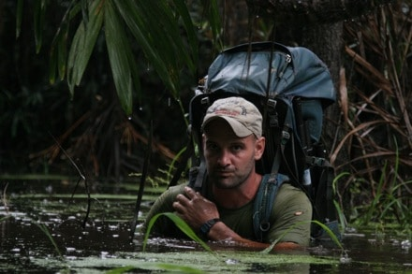

It took two years, four months, and one week. Bot flies burrowed into his scalp. Parasites attempted to use his body as a host. He encountered giant anacondas, slogged through mud, and hacked through dense jungle. These are the joys Ed Stafford battled on a daily basis as he walked the entire length of the Amazon River. This, the longest* river in the world, begins as a barely-trickling stream high up in the Peruvian Andes and slowly becomes the most voluminous river in the world as it winds its way to the Atlantic Ocean at the eastern coast of Brazil. Ed Stafford, a mere mortal, covered over 4,000 miles of some of the most treacherous terrain that exists on earth, by foot.
Stafford, like many modern-day explorers, has the unique ability to blend adventure with philanthropy, using his expedition as an avenue to raise awareness of the environmental issues that plague the Amazon region. While he was in the military, he received his training in Central America and the Far East. In those places he witnessed the mass destruction of tropical forests from the endless expansion of unchecked agriculture, the illegal logging of old-growth trees, and the slash and burn decimation of acres and acres of jungle. His desire to accomplish a “world-first” and his passion for the environment led him on one of the most impressive adventures to date.
Stafford now has plans for another “world-first,” and though he will not divulge the details for fear of someone else beating him to the punch, he made a guarantee to Outside Magazine that it will be “bloody difficult.” He’ll set off for this new expedition next January.

*The true source of the Amazon is widely debated, and depending on where that source is, some argue that the Nile River is in fact the longest river in the world

Jessica Watson – Circumnavigator
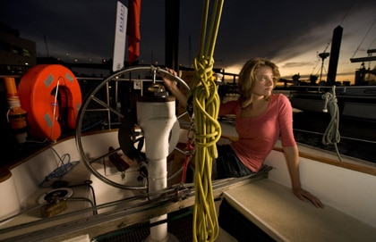
Jessica Watson was eleven years old when she first heard the story of Jesse Martin, the 18-year old who, in 1999, became the youngest person to complete a non-stop, solo circumnavigation of the globe. The story stuck with her, and by the time she was thirteen she informed her parents that she intended to do the same thing.
Watson’s trip was controversial before it even began, with many critics fuming over the debate of “how young is too young?” She was too inexperienced, too immature, and far too young to endeavor into something so dangerous, they claimed. To add fuel to their fire, during a sea trial, her sailboat, Ella’s Pink Lady, collided with a 63-ton, 738-foot bulk carrier, which resulted in a broken mast that she had to tend to before her official launch. Having dealt with the problem successfully and with confidence, she later wrote that, “Any doubts about whether I could cope mentally…vanished.”
It wasn’t all smooth sailing after that first collision either; she experienced a “ferocious” Atlantic storm “with 4 knockdowns in one night…winds over 75 knots and waves of 15 meters and higher.”
Nevertheless, On March 15, 2010, after sailing for 210 days straight, Jessica Watson became the youngest person to circumnavigate the world–solo, unassisted, and non-stop. She completed her circumnavigation when she landed in Sydney Harbor three days before her seventeenth birthday. Yeah, she did this at the age of sixteen.
Since returning, a documentary film has been made about her voyage, and she has written a book titled True Spirit.

Eric Larson – Polar Explorer
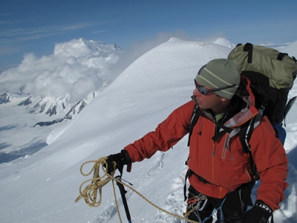

For fifteen years Eric Larson has been exploring the poles, adventure racing, and dog mushing. He is a man awed by the environments he encounters and drawn to frigid climates, with a personal motto of, “It’s cool to be cold.”
Throughout his years of adventuring, he has been witness to the rapid disappearance of the polar regions that he so loves. For this reason he began his Save the Poles project–a 365-day expedition to the “Polar Trifecta.” That is, the South Pole, the North Pole, and the summit of Mount Everest. This was an unprecedented, single-year tour-de-force beginning in November of 2009 and concluding in October of 2010. Braving -50 degree temperatures, Larson snow-shoed, skied, and swam across the Arctic, all while gathering scientific data and filming a documentary as he went. He braved whiteouts in Antarctica and avoided avalanches on the formidable slopes of Everest. He traveled along thinning Arctic ice that would bend and fracture underneath his team’s skis and campsites, sometimes “opening [up] gaping holes of icy water near where they slept,” reported Outside Magazine.

“On an expedition, there is you and there is ice (or rocks or water) and doing a long carry, skiing into the wind, waiting for weather and more can all make time slow to a crawl. Minutes seem like hours. Days seem like weeks. It can be agonizing on a good day.”

David de Rothschild – Voyager
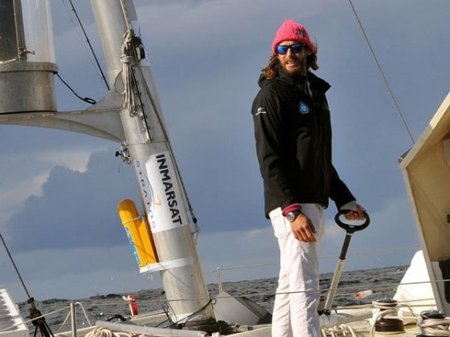
As the youngest heir to his family’s banking fortune, Rothschild is not a person who uses his wealth as an excuse to be stagnant. His adventure accomplishments are vast: In 2006, he was the youngest British citizen to ever reach both geographical poles after spending 100 days crossing the Arctic from Russia to Canada. Prior to that, he had been part of a team who claimed the record for the fastest crossing of the Greenland Ice cap, and he is one of only fourteen people to ever traverse Antarctica.
Like Stafford, Larson, and other current explorers, David de Rothschild’s focus is to raise awareness about various environmental issues that are threatening the world’s natural wonders. Named one of the “Adventurers of the Year” by National Geographic Magazine, his most recent trip was a Pacific Ocean crossing aboard “Plastiki,” a catamaran made almost entirely of recycled plastic material, including some 1,200 plastic bottles. Batteries powered by solar energy charged Plastiki’s electrical components, and fresh water was made possible by a small, onboard desalination device. The mission of the expedition was to reach and study “Plastic Island,” a floating swath of garbage that has accumulated in the mid-Pacific ocean, believed to be nearly twice the size of the state of Texas.
De Rothschild announced the idea four years prior to the actual launch of Plastiki. In the spring of 2010, Plastiki and the crew sailed into the Pacific Ocean. They traveled 9,500 miles, visited various points of ecological interest, and then on July 26th, 2010, they completed their journey when they reached Sydney Harbor, greeted by cheering crowds.

Andrew Skurka – Alaska-Yukon Explorer
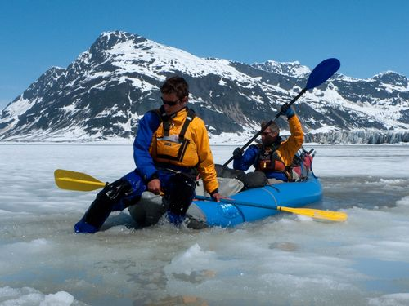
“My primary goal in attempting the AYE is unabashedly personal: I want an exceptionally unique, rewarding, and challenging experience…it makes me feel alive, like I am capitalizing on the 70-or 80-year-long opportunity I have to experience this world.”
The Alaska-Yukon Expedition (AYE) is Skurka’s most recent and perhaps boldest expedition yet. A circumnavigation of some of Alaska’s most rugged wilderness, the nearly 4,700-mile route included traverses of the Alaska and Brook’s Ranges, winded through six US national parks, two Canadian parks, and involved floats on “some of America’s wildest rivers, including the Copper, Yukon, Peel, and the Kobuk River.” Some 45% of the route was off-trail and still he managed to average 27 miles per day. Though most of the route had been previously explored, Skurka’s was the first attempt at doing it all in one big push.
By beginning in March of 2010, he was able to avoid some of the toughest of the Arctic’s winter; still, approximately 24% (over 1,000 miles) of the trip had to be covered on skis along the Iditarod Trail and in the Alaska Range until the spring snowmelt came. The remaining time was spent hiking and rafting (his raft was a 4.5-pound, blow-up “whitewater-worthy” packraft) in unruly country known for its bears, snow, raging rivers and a sheer immensity unlike anything in the lower 48.
Despite his significant previous experience (such as the 7,775-mile sea-to-sea epic he completed in 2005) Skurka told Adventure Running, that for this trip he was “more scared than [in] all of [his] previous trips combined.” At one point he had gone over 650 miles without seeing another human, and in the Yukon, he was “3-4 hours from the nearest settlement…by helicopter,” making for a nerve-wracking and stressful journey. Nevertheless, on September 5, 2010, he walked into the tiny town of Kotzebue 176 days after he had first left, as the first person to complete the route.
Be sure to listen to our podcast with modern-day adventurer Laval St. Germian

Erden Eruç – Human Powered Adventure
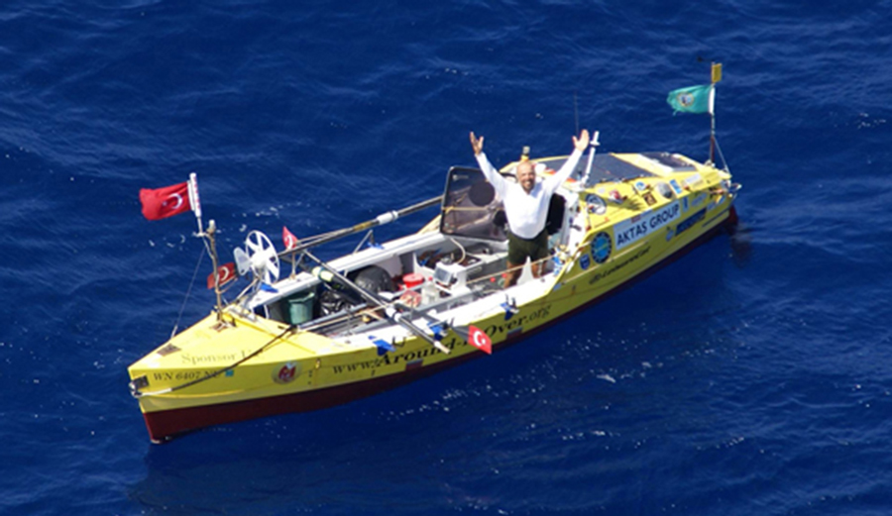
Eruç aboard his 23 foot ocean rowboat, Calderdale, in the Indian Ocean.
At 41 years old, after an education in engineering and a long career in consulting, Erden Eruç left his so-called “real job” to pursue his passion for human-powered outdoor adventures. For his warm-up” journey, Eruç loaded a touring bicycle and trailer up with the necessary high-altitude mountaineering gear and set out from his home in Seattle in February 2003. He rode up to the edge of Denali National Park, snowshoed in to the Kahiltna Glacier base camp, and climbed to the summit of Denali on 29 May 2003. Then he loaded up his kit and rode home.
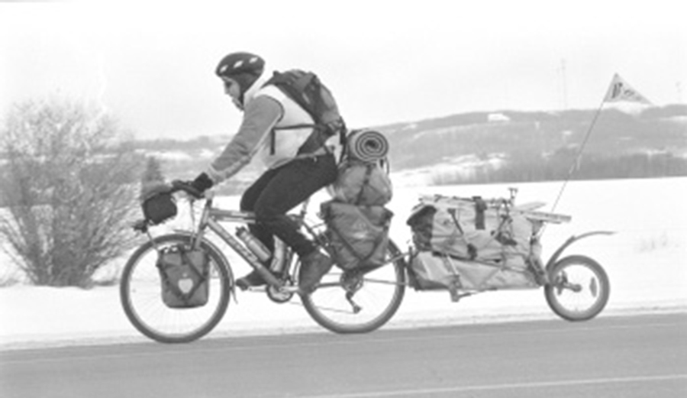

Thus began his Six Summits Project, with the goal to climb the highest peaks on every continent except Antarctica after reaching them by human power alone. The effort was inspired by the death of Eruç’s climbing partner, Göran Kropp. Beginning in 1995, Kropp rode a bicycle from his native Sweden to Nepal and climbed Mount Everest. Several years later, Kropp was tragically killed in a climbing accident in Washington — in 2002, Eruç was belaying him when he fell 60 feet after a piece of protection didn’t hold and a carabiner broke.
Inspired by Kropp and driven by his own unfathomable motivations, on July 10, 2007 Erden Eruç set out to become the first person to circumnavigate the globe by human power alone. The first 312 days were dedicated to rowing across the Pacific Ocean, from California to Australia. Eventually successful, his incredible solo journey covered 41,196 miles by rowboat, sea kayak, touring bicycle, and foot.
He started a non-profit organization, Around-n-Over, with the aim of educating children around the world through his travels and raising money for various charities. Along the way Eruç took side trips to climb Mount Kosziusko in Australia and Mount Kilimanjaro in Africa, and has so far completed half of his Six Summits Project. With the summits Elbrus, Aconcagua, and Everest remaining, Erden Eruç has much more adventuring ahead of him.

As so eloquently stated on Around-n-Over.org: “Why is it that we accept as final our boundaries, and never reach beyond them?”
Follow Erden Eruç on Instagram.

Kt Miller – Skiing Documenting Climate Changes
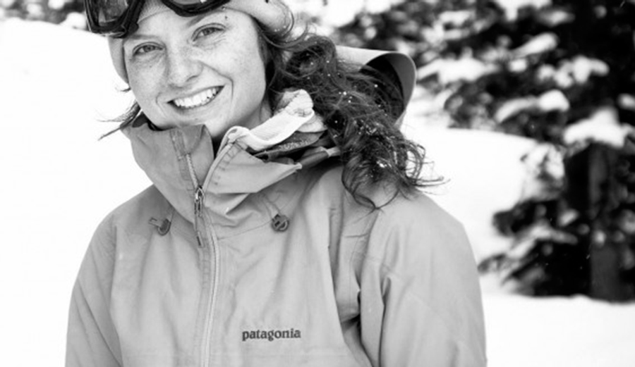
Photo: Shifting Ice
I met Kt Miller on a skinning trip in Cooke City, Montana last winter. After a week with a crowd of grungy mountain men I was instantly taken by her effervescent personality and thoughtful optimism. Little did I know, Miller is an incredibly talented skier and photographer on the verge of redefining much of the ski industry.
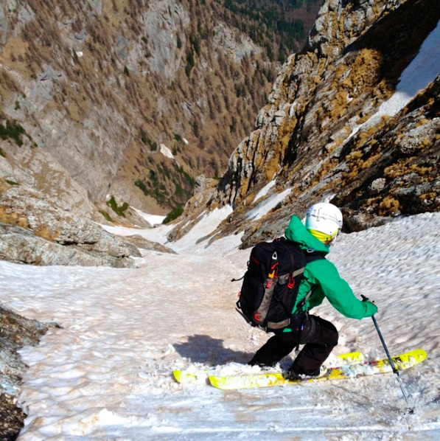
Miller has found her way into photographing some of skiing’s most innovative expeditions in the past few years — Alaska and Romania and her native Beartooth Mountains outside of her hometown of Bozeman, Montana. She claims that before she was six months old she was skiing around Bridger Bowl in her dad’s backpack; now, at 24, Miller is a leading light in the big mountain ski world.

Miller ripping couloirs in the Alps of Romania. Photo: Beau Fredlund via Shifting Ice
After a stint in photography school Miller made her way back to the mountains and found a way to unite her passion for skiing with camera in hand. It didn’t take long for me to realize why she has been called on by some of the industry’s biggest players — Backcountry Magazine, Patagonia, Zeal: I just needed to try to keep up with her leading the crew up the skin track. Her hard work and talent have landed her sponsorships from Dynafit and Lowepro.
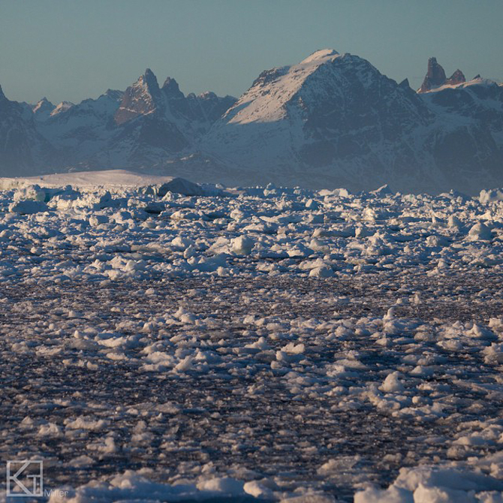
Pack ice in Greenland. Photo: Kt Miller via Shifting Ice
Miller is more than a solid photographer who can rip, though. Along with her positive attitude, she brings a thoughtfulness and respect for the mountains into every project; rather than “bigger, higher, harder,” she considers the meaning behind her objectives.
Advertisement
In Spring 2014, Miller was a member of the all-female Shifting Ice, Changing Tides expedition. The five set sail from Iceland, bound for Greenland. The purpose of the journey was to document and raise awareness of climate change and to ski first descents on the island of Greenland, all while inspiring other women to adventure and explore.
Kt Miller has a long career ahead of her — keep an eye on this one.
Follow Kt Miller on Instagram

Matt Rutherford – Sailing Plastics Pollution Explorer
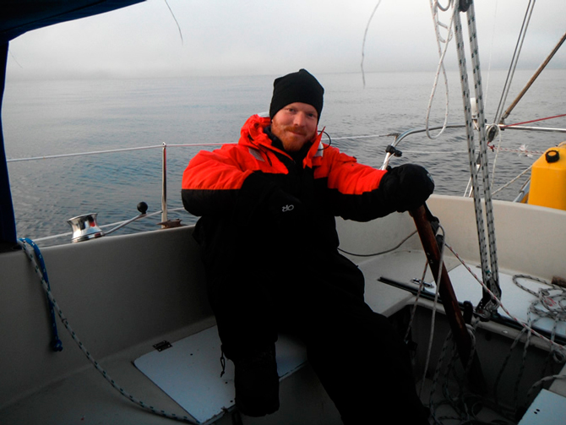
Photo: Red Dot on the Ocean
Matt Rutherford had a rough childhood. Growing up in Annapolis, he struggled with learning disabilities and acted out. At 17, he found himself sitting in a jail cell contemplating his life trajectory. Some switch flipped and he decided to commit blindly: Rutherford bought a sailboat off the internet and taught himself how to sail. Four years later he embarked on a successful double trans-Atlantic single-handed sail on his 32-foot Pearson sloop. That is, he sailed from Maryland to Europe and back, alone.
For most sailors this would be accomplishment enough (single-handing a small sailboat across an ocean is not for the faint of heart). But Rutherford, as an explorer does, wanted to push his boundaries.
On June 11, 2011, Rutherford set out from Annapolis, MD on a small Swedish-built sailboat on an attempt to circumnavigate the Americas, single-handed, non-stop. 309 days and 27,077 nautical miles later Matt Rutherford became the first person in history to solo through the Northwest Passage, down the Pacific coast of the Americas, around Cape Horn, and back to his starting point. He did not touch land the entire journey: any supplies were transferred to him at sea. The voyage was for charity — Rutherford was supporting Chesapeake Regional Accessible Boating, an organization dedicated to providing disabled people with the chance to sail. He had no radar on board: “If you die doing what you love, it’s not a tragedy…”

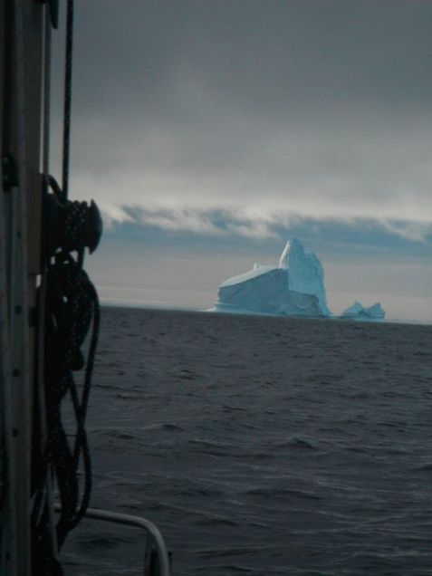
A photo taken by Matt Rutherford from aboard his Albin Vega sailboat in the Northwest Passage. Photo: Red Dot on the Ocean
The Northwest Passage was first successfully sailed in 1906 by the Norwegian explorer Roald Amundsen (the same one who was the first human to the South Pole, and the first to undisputedly reach the North Pole). This treacherous route through the Arctic has only recently become possible to unfortified vessels; in 2007 the European Space Agency announced that pack ice in the Arctic had receded enough for a navigable route water route to open for boat other than Arctic ice-breakers.
Since his accomplishment, Matt Rutherford has set to pursuing scientific research by sail. He founded the Ocean Research Project and led the Trans-Pacific Plastic Pollution Survey, a 7,000 mile sail from Sausalito, CA to Yokohama, Japan collecting information and samples for analysis by various scientific groups. He continues his work to understand the Earth’s oceans and to educate people on how to preserve this resource

James Balog – Photography Explorer

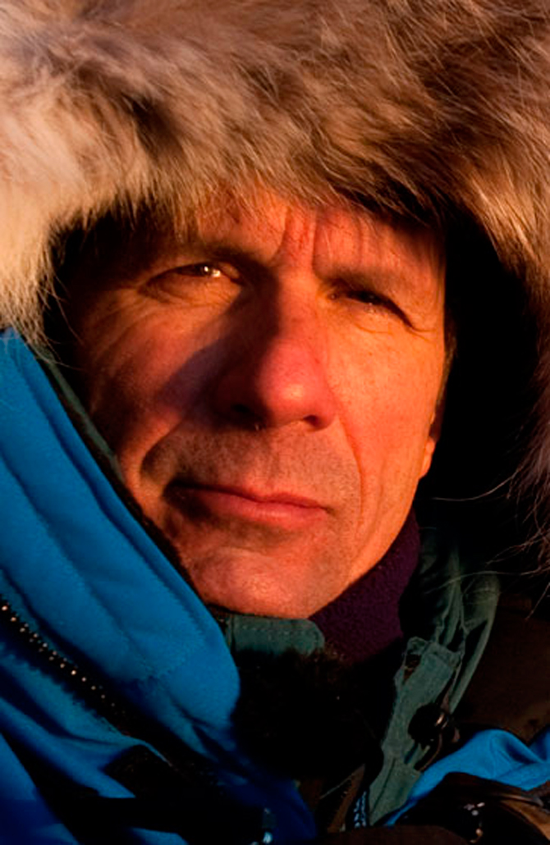
Photo: Nikon
James Balog tries to pop our bubbles of reality through his photography: “Photographers are like the antennae of civilization. We are an integral part of the sensing mechanism of the human animal. We are out there feeling in the darkness, trying to see what’s around us and reveal what hasn’t been revealed before.”
While an undergraduate at Boston College, Balog discovered a deep love for the outdoors and witnessed the birth of a lifelong passion for mountaineering. After cutting his teeth in the White Mountains of New Hampshire, he began traveling much further afield to climb — Europe, Alaska, and Asia. Toting a camera along on his climbs, Balog realized that his passion for photography and adventure could be combined with the deep understanding of geomorphology he gained as a Masters student at the CU Boulder. And so he began a career as a professional photographer devoted to challenging humanity to consider their relationship with nature and how it could be improved.
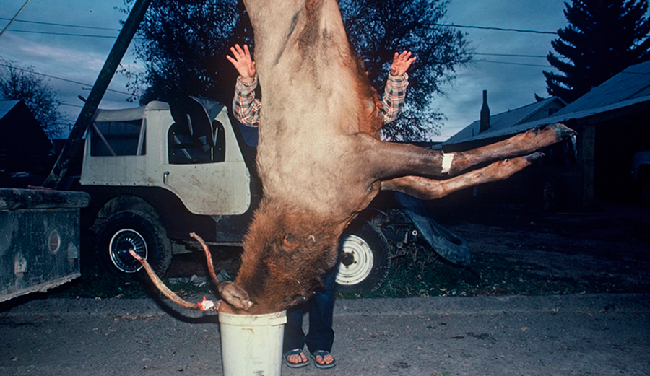
Hanging Elk in a Bucket, from Balog’s first book of photography, Wildlife Requiem, published in 1984.
Over the course of his thirty-year career, James Balog’s photography has been seen by millions, printed in books, magazines, and online, and made into films. More recently, Balog started the Extreme Ice Survey, a project with the aim of documenting the effects of climate change in an immediately graspable way.
Above: The trailer to Balog’s 2012 master stroke, Chasing Ice.
To do this, Balog and his team fixed high-resolution cameras to shoot time-lapse imagery of glaciers. His incredibly stirring results were presented in the 2012 documentary, Chasing Ice. This month Balog’s newest film project, 1000 Cuts, will debut at Mountainfilm in Telluride. The film documents the effects of oil drilling in one of America’s most beautiful and tenuous landscapes, the Greater Canyonlands of Utah.
Follow James Balog on Instagram.

Gerlinde Kaltenbrunner – Alpinists

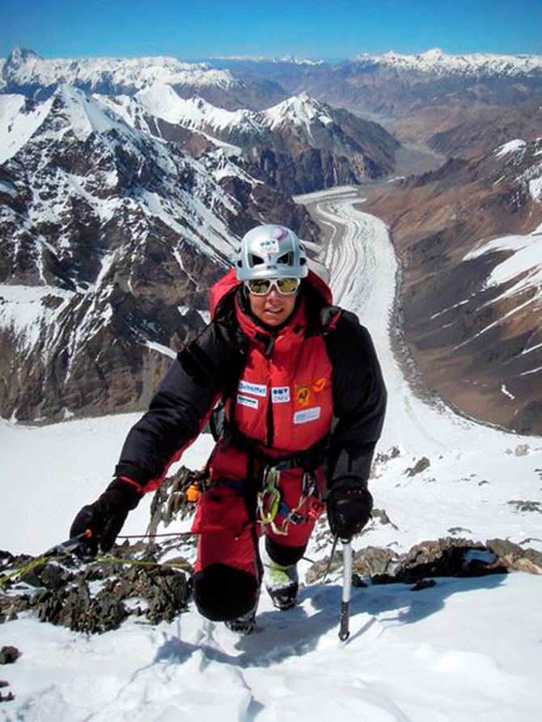
Photo: Vassiliy Pivtsov
Gerlinde Kaltenbrunner attempted K2 seven times before she reached its summit. She could have hired a high-altitude porter or brought an oxygen bottle to ease the journey — she opted against it. Kaltenbrunner is an idealist, and remained committed to her values through the duration of an ultimately successful 13-year journey to climb all the 8,000 meter peaks in the world.
Kaltenbrunner’s upbringing in a village in northern Austria injected a deep love for the mountains in her constitution. At 27, Kaltenbrunner summitted Cho Oyu on the Tibet-Nepal border and began the long relationship with the high Himalaya that culminated on the summit of K2 in August 2011. Just a year earlier Edurne Pasaban, a Spanish mountaineer, had become the first woman to successfully climb all the 8,000 meter peaks. However, Pasaban had used oxygen on Everest in 2001 and employs the use of high altitude porters. The two women often climbed together and both humbly denied the presence of a negative competitiveness between them — both were committed to the same goal, but didn’t see it as a race. Rather, it was a challenge, and they could help each other achieve that challenge.
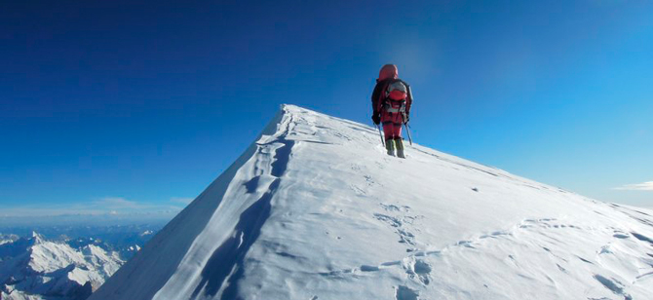
Photo: Gerlinde-kaltenbrunner.at
Kaltenbrunner and her husband, Ralf Dujmovits (another alpinist), are involved in a Nepalese charitable organization, Beilngries. The non-profit has built schools, health projects, and an orphanage in the Nepali Himalaya. Kaltenbrunner’s discipline, conviction, and strong ethical grounding have earned her a place amongst mountaineering’s venerable elite

Meet Sir Ranulph Fiennes, the world’s greatest living explorer
MATT PHILLIPS
Lonely Planet Writer
10 JANUARY 2020

Sir Ranulph Fiennes has been labelled the world's greatest living explorer by the Guiness Book of World Records, and some of his monumental efforts, such as travelling around the world's surface vertically, crossing both its poles in the process, have yet to even be attempted by anyone else since his doing so.
Yet this inspiring man, who has climbed both Everest and the North Face of the Eiger in his sixties, and even cut off his own frostbitten fingers in his garden shed, has some human frailties you wouldn't expect: a fear of heights and propensity to be lazy. Here, prior to an upcoming talk at The Adventure Travel Show, we sit down with the living legend to learn more about his life, his travels and his goals.
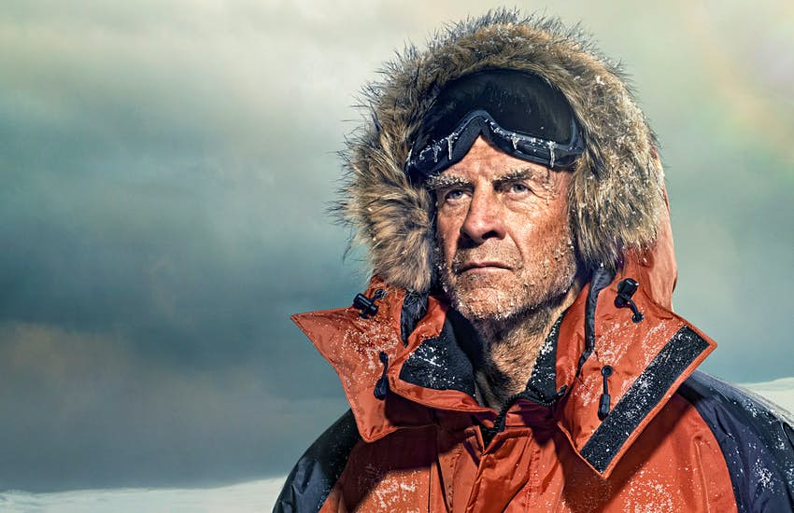
Sir Ranulph Fiennes, the world's greatest living explorer © garysalter
On your expedition up the White Nile in 1969 by hovercraft you didn’t even stop to see the Pyramids of Giza. Are travel and exploration good bedfellows, or can one get in the way of another?
During that expedition we were all on leave from the army, so the driving force in the back of our minds was that we wanted to cover the entire river, some 3000-4000km, in the time we had available. We needed to get back on time. To some extent, it was that I was fighting a war in Oman and we were outnumbered; if I turned up late from leave it would look like cowardice. So we had every reason mentally to be in a rush, and therefore we didn't slow down to appreciate local culture.
When you’re exploring without such tight time constraints, do you take the time to enjoy the surroundings or are you solely focused on the goal ahead?
It depends. If you’re in the Arctic or Antarctic, there is nothing to enjoy other than ice. There are no birds or animals or even bacteria. If there is something other than whiteness, then it is likely not a good thing. In the Arctic it means there is trouble; other colours there could mean open water, which you don’t want when you’re man hauling, or 10-20m high pressure ridges of ice blocks getting in the way. In the Antarctic its similar, changes of colour usually mean crevices. So in these environments, you want just whiteness and boringness. That said, when you're being paid to write a book about it, you want it to be exciting. Even if you have a thesaurus, 100,000 words to describe whiteness is challenging. Of course you don’t want people dying and falling into crevices on an expedition, but dramatic problems are helpful in filling pages.
What do you think about while moving through the whiteness?
You are constantly ensuring you are on the right bearing. You constantly wonder if you should be going a bit left, a bit right, a bit east instead of north-south to stop damage to the sled runners if you go through sastrugi at the wrong angle.
When you travel for leisure, do you still find yourself exploring? Whether in a city or wilderness area?
On a holiday? I have to say that I haven’t been on a holiday in years. And I’m not sure I can remember what one does on holidays. With my late wife Ginny I went on quite a lot of holidays. But now it’s mostly travelling for lectures. Before my daughter went to school, she and my wife Louise would travel with me. By the time Elizabeth was four she already had more than a 100 stamps in her passport.
So does your daughter have the travel bug?
I think she had enough of it when she was little. When on airplanes I can remember my wife would sit on the aisle, me at the window and Elizabeth in the middle. She used to stand up on her seat when Louise was asleep and tickle the head of the person in the row in front of her. Needless to say, sometimes those passengers didn’t have a sense of humour.
Speaking of growing up, who was your biggest influence?
My dad. His life inspired me to want to be what he was: Colonel of the Royal Scots Greys regiment. But because I didn’t get A levels I couldn’t get to Sandhurst, which meant I couldn’t rise above the rank of captain.
He passed away before you were born, was it your mother who regaled you with stories of him?
Yes, she certainly did. And when I went into the army – I joined the regiment 18 years after the War – there were quite a few who still remembered my dad, all with affection. His nickname was “Lugs”. He must have had big ears, although in the photos I’ve seen they don’t look big. But someone who knew him said they were like Tony Blair’s.
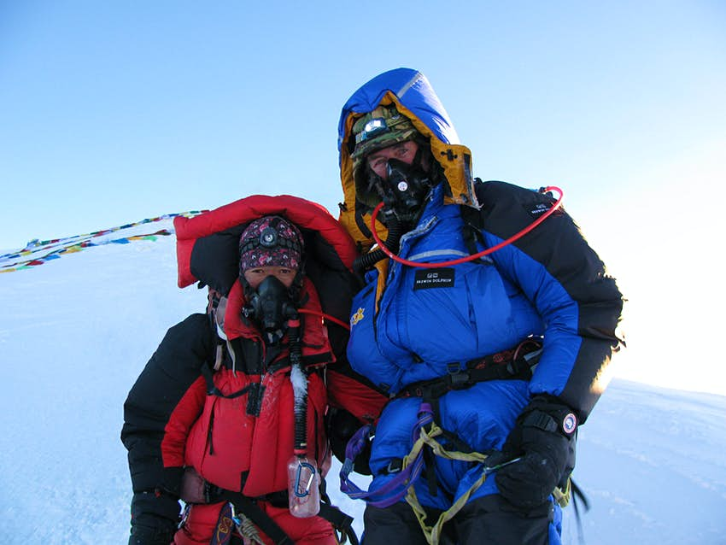
Sir Ranulph Fiennes and his Sherpa climbing partner on the summit of Mt Everest, the world's highest point © Sir Ranulph Fiennes
Some of your expeditions, such as summiting Everest at the age of 65 have received much press and accolades. Are there some that were a particular favourite of yours that didn’t get the hype you thought they’d deserve?
The Transglobe Expedition was really the first trip around the Earth vertically, and yet because PR wasn’t something we knew about in those days the journey wasn't widely reported. Somebody did manage to get the Observer to provide exclusive coverage, but that only managed to dampen down general press coverage because other papers couldn't run it. So it wasn’t until two years through the expedition, after completely crossing Antarctica (which had never been done by a single team before) and on our way up through the northwest passage – the first open boat journey through the route – that our expedition became known to the greater public. And that was only because ITN captured footage of our base camp virtually burning to the ground.
One of your lesser-known expeditions that caught my attention was your long search for the lost city of Ubar in Oman.
Yes, that was actually eight different expeditions in the same desert. It wasn’t until the last one that we actually found the city. In the end it was good luck rather than anything provided to us by NASA. The space agency helped us find where it wasn’t, which was actually useful via elimination. Yet it came down to me overhearing some officials from the Oman's Ministry of Heritage speaking on the other side of a building (they didn’t know I was listening); they’d come to the conclusion that our American film crew were happy to just be in the country to filming pots of Dhofar, and had no intention of finding Ubar. With fear that they'd report us to the Sultan, who'd only given us permission to film as part of a search for the lost city, I rushed to our archaeologist and said: “Yuri! You have to get your team to start digging or these officials are going to go to the Sultan and saying we are not genuine.” Reluctantly, he got his team to start digging near our base camp where there was a waterhole. Within three days Yuri was plucking out 2000-year-old chess sets. And that was that, we’d found the city.
You’ve mentioned luck in a lot of your books. Is it just pure luck, or do you think manufacture your luck with hard work and preparations?
Oh, very much the former. Shackelton’s great word was "provi" for providence, and he too was a great one on luck of the Irish.
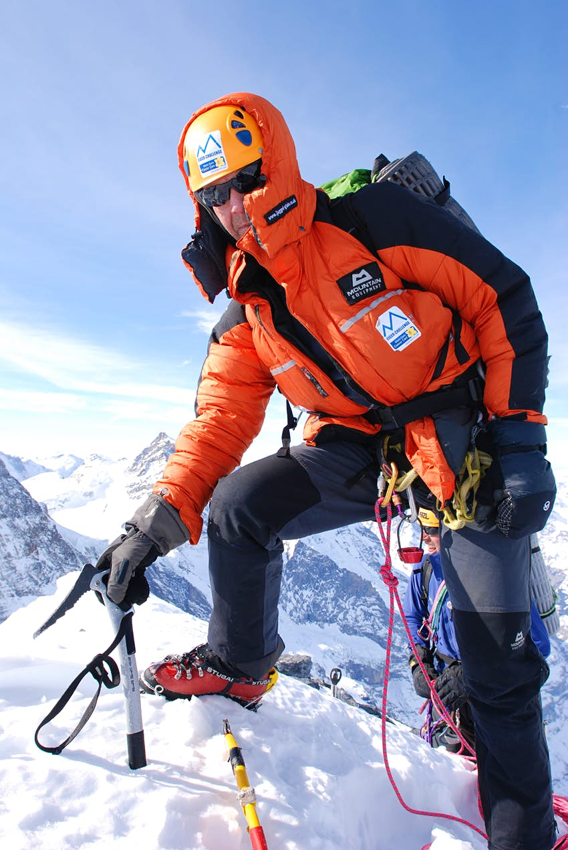
Despite vertigo, Sir Ran climbed the North Face of Eiger in 2007, raising £1.8 million for Marie Curie Cancer Care © Ian Parnell
You’ve climbed Everest, Kilimanjaro, Elbrus and even the North Face of the Eiger, what is your favourite climb?
My least favourite is anything that has drops. Everest doesn’t have drops. On either of the standard routes up the mountain you have a rope, and when you look down you have a white slope; not a white drop, but a white slope. And it’s the drop that gives me vertigo. The last bit of the climb before the summit has a bit of a drop at the Hilary Step, so we did it at night so that I couldn’t see it.
Given your battles with vertigo, how did you handle the North Face of the Eiger?
I hated the Eiger. It cured me of ever wanting to go up another mountain.
What would be your darkest moment of any expedition?
That is not an easy one to answer. If someone had ever died, I would have said that.
And what would be your highest moment on expedition?
I would say it was on the Transglobe Expedition. It had taken us seven years of working unpaid full time to plan and get 1900 sponsors, and three years of constant travelling from setting out to finish – 10 years of our lives – and knowing we might fail at the last minute, which we nearly did, made completing the last hurdle a highlight. It was when our ice flow, on which we’d been floating for three months in the Arctic, came into sight and then touching distance of our waiting ship (also lodged in ice). The odds of our ice flows meeting must have been 10 to one against.
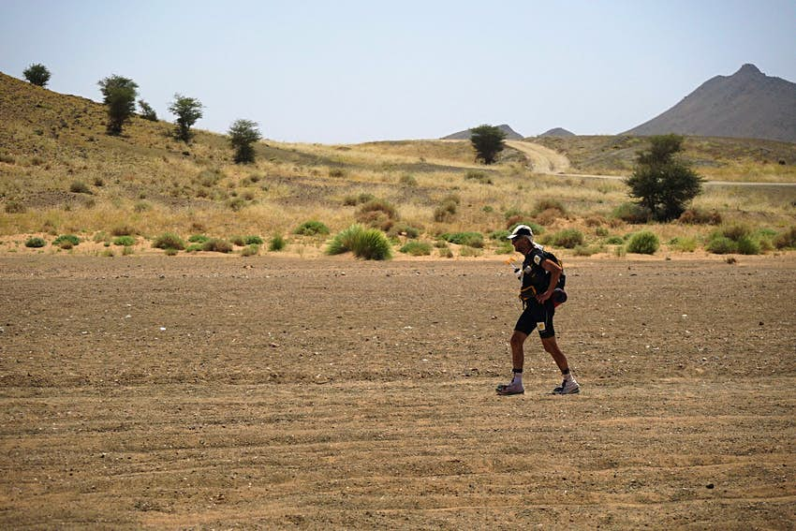
Sir Ran competing in the Marathon des Sables, which crossed 256km of desert in just six days © Fieldcraft
Given your polar expeditions, and having also taken on and completed the Marathon des Sables, is cold or heat your bigger adversary?
Cold is more difficult, but don’t underestimate the difficulty of keeping cool in the heat.
How do you manage risk?
I carefully study why my predecessors have failed at similar records, and it’s always because they hit a risk. And while those expeditions did their best to try and work out a way to overcome that risk, I don't think of another way to solve it. Instead, I take the approach that it’s better to just try and avoid that risk altogether, even if it meant going extra days in the wrong direction.
How to you weed out the thousands of applicants for your expeditions?
I paint a black picture. On one occasion I needed to pick just two people out of 8000 applications, so we warned all of them that I’m horrible, the expedition would be horrible – no pay, no expenses, nothing for three years, no glory. Those that stay can’t complain. I also make all applicants join the territorial SAS.
Were you born a leader, or did some experiences turn you into one?
I wouldn’t say that I’m a born leader. I just much prefer to be the leader than to suffer the consequence of someone else’s bad decisions.
I’ve read that you’ve said your worst attribute is that you have to fight against laziness – given your record of achievements, I find that hard to believe. How did you overcome it?
I don’t think I did.
How does your kit bag differ now that from your early days of exploration? Any invaluable piece of kit you can longer do without?
I don't go anywhere without GPS, satellite navigation and a satellite phone. Those three things now make things considerably different at the end of the day. In the early days, after 10 hours of man hauling, while the other bloke is setting up the tent and getting coffee ready, you – at your coldest – would be setting up a trident, getting the bubbles level, likely having to take your gloves off now and again. Then you'd need to struggle with the nautical almanac and sight reduction tables. Now if you want to know where you are you simply grab a coffee and press a button on your sat phone.
You’ve made a habit of achieving incredible "firsts" in the world’s polar regions. What made you first look at the poles as a target?
It was really the Transglobe Expedition, which took in both poles. After that success, we started getting more specific with polar firsts, whether unsupported, with no machinery etc.
What is the greatest polar challenge left?
I know what it is. I failed attempting it three years ago. Crossing Antarctica during the polar winter.
How do you think climate change will affect polar exploration?
In the Arctic it already has. There is more water and less ice. In Antarctica it will change much more slowly due to the sheer amount of ice atop the landscape.
What is next?
My exploration partners – Anton Bowring, Mike Stroud and Oliver Shepherd – are looking at it at the moment, but the only thing I can say without alerting the opposition is that it is north and not south.
What would you like to see as your legacy?
I haven’t really thought about it. When you’re dead, you’re dead. It doesn’t really matter.

